Contextual Synonyms

🔹 What is Contextual Synonyms
# Source: Chatgpt (GPT-4-turbo) at [7/30/2025]
Contextual synonyms are words that function as synonyms only in specific contexts—they can replace each other in certain sentences but not universally.

🧠 Definition:
# Source: Chatgpt (GPT-4-turbo) at [7/30/2025]
Contextual synonyms are words that share a similar meaning only within a given context, but may differ in other situations, due to connotation, collocation, or domain.
These synonyms rely on the surrounding words and meaning to work interchangeably.

📌 Key Features:
# Source: Chatgpt (GPT-4-turbo) at [7/30/2025]
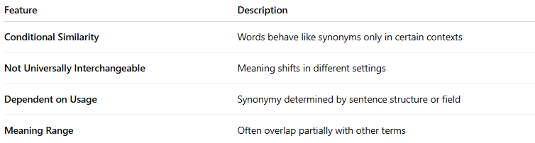
Feature | Description
Conditional Similarity | Words behave like synonyms only in certain contexts
Not Universally Interchangeable | Meaning shifts in different settings
Dependent on Usage | Synonymy determined by sentence structure or field
Meaning Range | Often overlap partially with other terms

📚 Examples of Contextual Synonyms:
# Source: Chatgpt (GPT-4-turbo) at [7/30/2025]
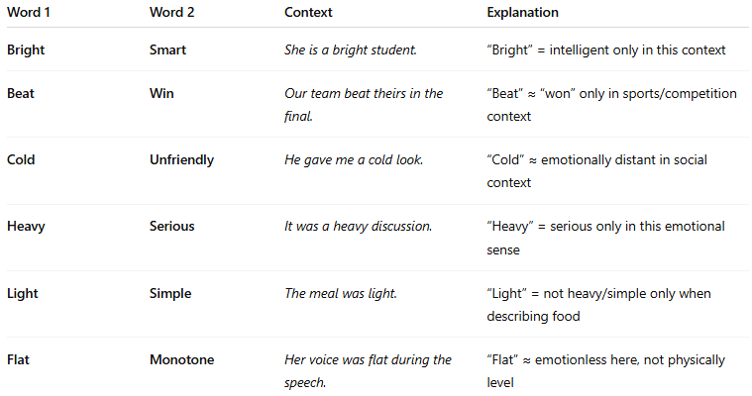
Word 1 | Word 2 | Context | Explanation
Bright | Smart | She is a bright student. | “Bright” = intelligent only in this context
Beat | Win | Our team beat theirs in the final. | “Beat” ≈ “won” only in sports/competition context
Cold | Unfriendly | He gave me a cold look. | “Cold” ≈ emotionally distant in social context
Heavy | Serious | It was a heavy discussion. | “Heavy” = serious only in this emotional sense
Light | Simple | The meal was light. | “Light” = not heavy/simple only when describing food
Flat | Monotone | Her voice was flat during the speech. | “Flat” ≈ emotionless here, not physically level

🧾 Why Context Matters:
# Source: Chatgpt (GPT-4-turbo) at [7/30/2025]
Words like “sharp” can mean:
- Intelligent (sharp student)
- Painful (sharp pain)
- Precise (sharp edge)
Only in some contexts does “sharp” share meaning with synonyms like “smart,” “pointed,” or “sudden.”

🔁 Comparison with Other Synonym Types:
# Source: Chatgpt (GPT-4-turbo) at [7/30/2025]
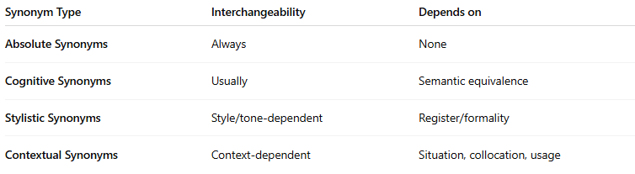
Synonym Type | Interchangeability | Depends on
Absolute Synonyms | Always | None
Cognitive Synonyms | Usually | Semantic equivalence
Stylistic Synonyms | Style/tone-dependent | Register/formality
Contextual Synonyms | Context-dependent | Situation, collocation, usage

